**Day 7: Heatmap analysis**

**Objective : To plot a heat map and understand the differential expression based on numbered data.**

**Problem statement Or research question: To identify over expression of genes in different strains.**

**Input details  
1. Gene(s) Name: ACE 2**

**2. Protein(s) Name (transcriptome details): ACE 2**

**Input data Table**

|  |  |  |  |  |  |
| --- | --- | --- | --- | --- | --- |
| **ORF** | **Alpha** | **Beta** | **Gamma** | **Delta** | **Omicron** |
| **ORF1a** | **5** | **4** | **3** | **2** | **1** |
| **ORF1b** | **4** | **3** | **2** | **1** | **0** |
| **ORF3a** | **3** | **2** | **1** | **0** | **-1** |
| **ORF6** | **2** | **1** | **0** | **-1** | **-2** |
| **ORF7a** | **1** | **0** | **-1** | **-2** | **-3** |
| **ORF7b** | **0** | **-1** | **-2** | **-3** | **-4** |
| **ORF8** | **-1** | **-2** | **-3** | **-4** | **-5** |
| **N** | **0** | **1** | **2** | **3** | **4** |
| **M** | **1** | **2** | **3** | **4** | **5** |
| **S** | **2** | **3** | **4** | **5** | **6** |
| **L** | **3** | **4** | **5** | **6** | **7** |
| **ORF10** | **4** | **5** | **6** | **7** | **8** |

**Output heatmap:** 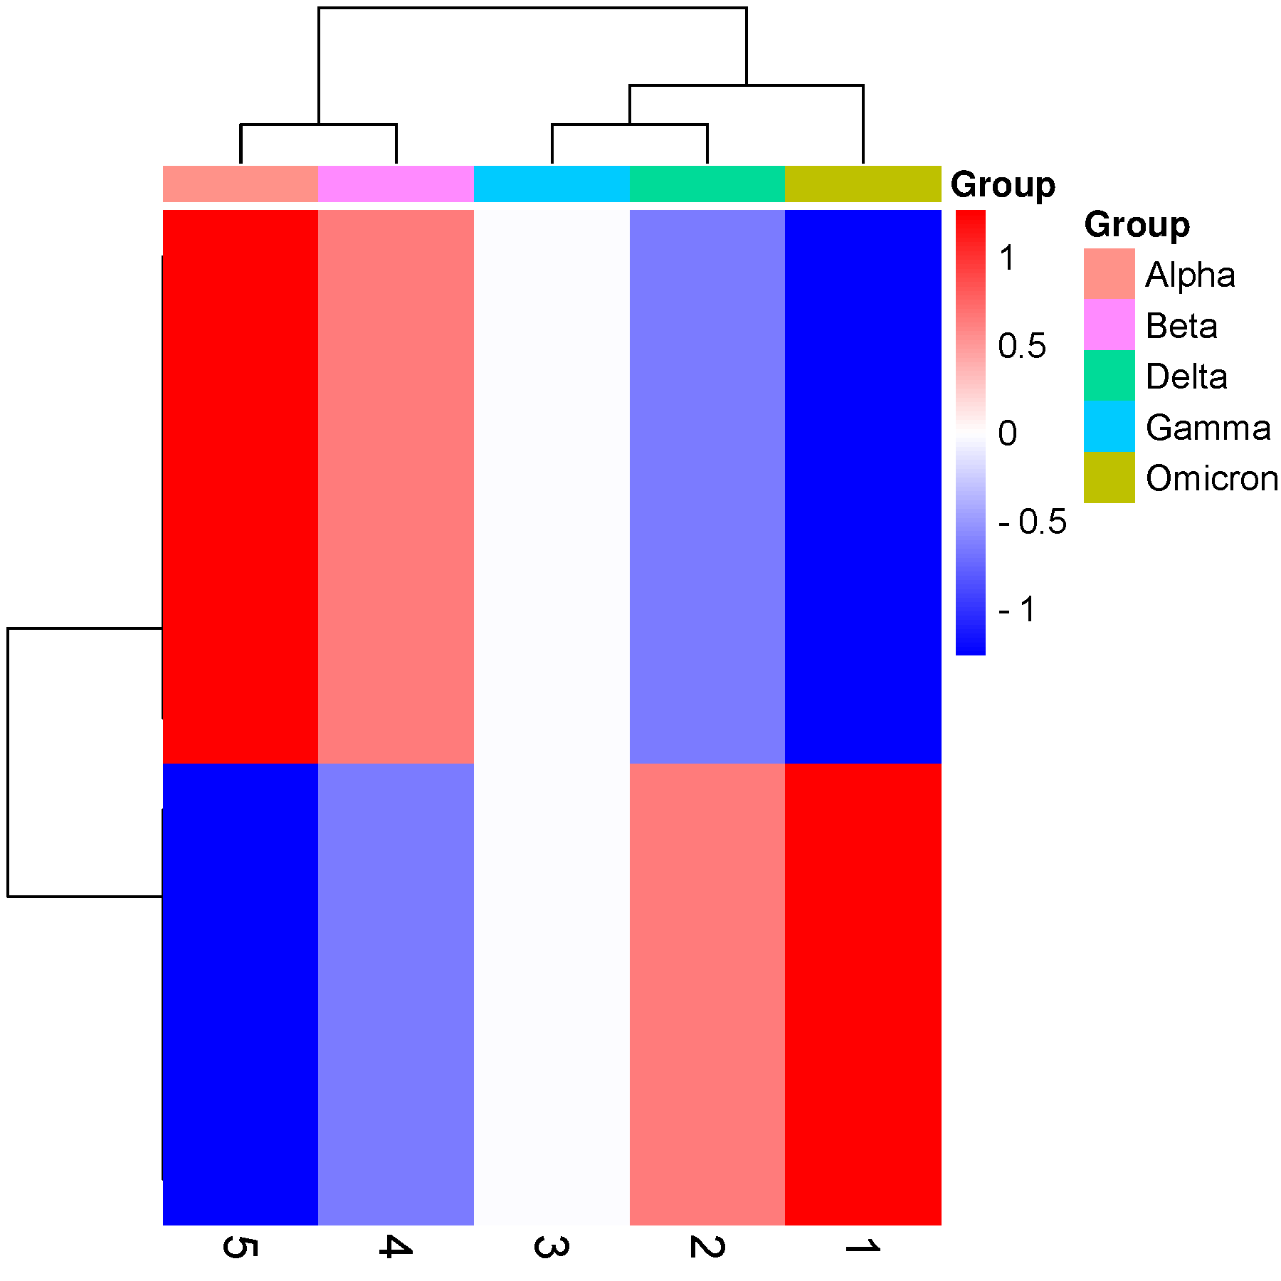

**Discussion points: To study GMO, to study epigenetic effects and to know how are biomarkers found.**

**Five interpretation points understood:**

**1) Alpha has stronger expression.**

**2) ORF1a is most virulent in Alpha than ORF8 in Omicron.**

**3) ORFN to ORF10 are stronger ORFs in these strains.**

**4) ORF1a to ORF8 has very less impact though they are present in all other strains.**

**5) ORF8 is more expressed in Alpha strain than in Omicron.**

**Day 8 & 9: Homology Modelling:**

You can choose any protein which is involved in SARS CoV-2 Pathogenesis (Eg: ACE2 receptor, Any envelope protein) and can take at least 2 homologous sequences with sequence similarity >30%. Try to develop an hypothesis around it (Like Why you want to use Homology modelling for your protein of interest, Purpose and outcome of it) and more importantly how it is going to add value to your hypothesis.

HYPOTHESIS – Entry level antagonist to inhibit the ACE 2 receptor which actually inhibit receptor and virus binding. We use homology modeling to visualize 3D structure of ACE2 receptor to study the interaction profile of drug X.

**Protein:** Angiotensin-converting Enzyme 2

**Gene:** ACE2

**PDB:** Q9BYF1 (First Isoform)

|  |  |  |
| --- | --- | --- |
| **Target** | **Sequence** | **Result** |
|  |  |  |

**Day 10:**

Please paste your GitHub account link: